73.03.29
To John Kerr
D73/4020, unit 663, VPRS 3991/P inward registered correspondence, VA 475 Chief Secretary's Department, Public Record Office, Victoria.

Melbourne bot. Garden
29/3/73
The Chief Inspector of Stock

Sir
In reply to your communication just received I have the honor to inform you, that the herb, which produced poisonous effect on the cattle of Broadmeadows is the Solanum nigrum, called in Britain the annual Nightshade. It is a cosmopolitan plant, since ancient times known as poisonous and mentioned under the name of Strychnos along with Atropa Belladonna in the writings of Dioskorides already, it belonging indeed with the Belladonna and Mandragora, Stramonium to the same order of plants (Solaneae). The most active principle of Solanum nigrum is a Glucosid, Solanin, and this is most strongly developed in the unripe berries. The plant however acts not with the dreadful intensity of the deadly Nightshade (Atropa Belladonna); but it is far more commonly dispersed, and disseiminates itself with celerity, particularly on roadsides, waste places, in gardens &c. It being however an annual, it can be readily enough destroyed by weeding prior to its ripening its berries. The Solanin produces paralysis of the extremities prior to death, when consumed in quantity.
I have the honor to be your obedient
Ferd. von Mueller,
Direct. botan. Garden.

Atropa Belladonna
Mandragora
Solaneae
Solanum nigrum
Stramonium
Strychnos

For a published version of this letter see B73.07.02.
See J. Kerr to M, 28 March 1873 (in this edition as 73-03-28b).
Vic.
Marginal annotation in an unknown hand: 'Take in plate'. The printed version includes a plate of Solanum nigrum: 73-03-29_image01.jpg 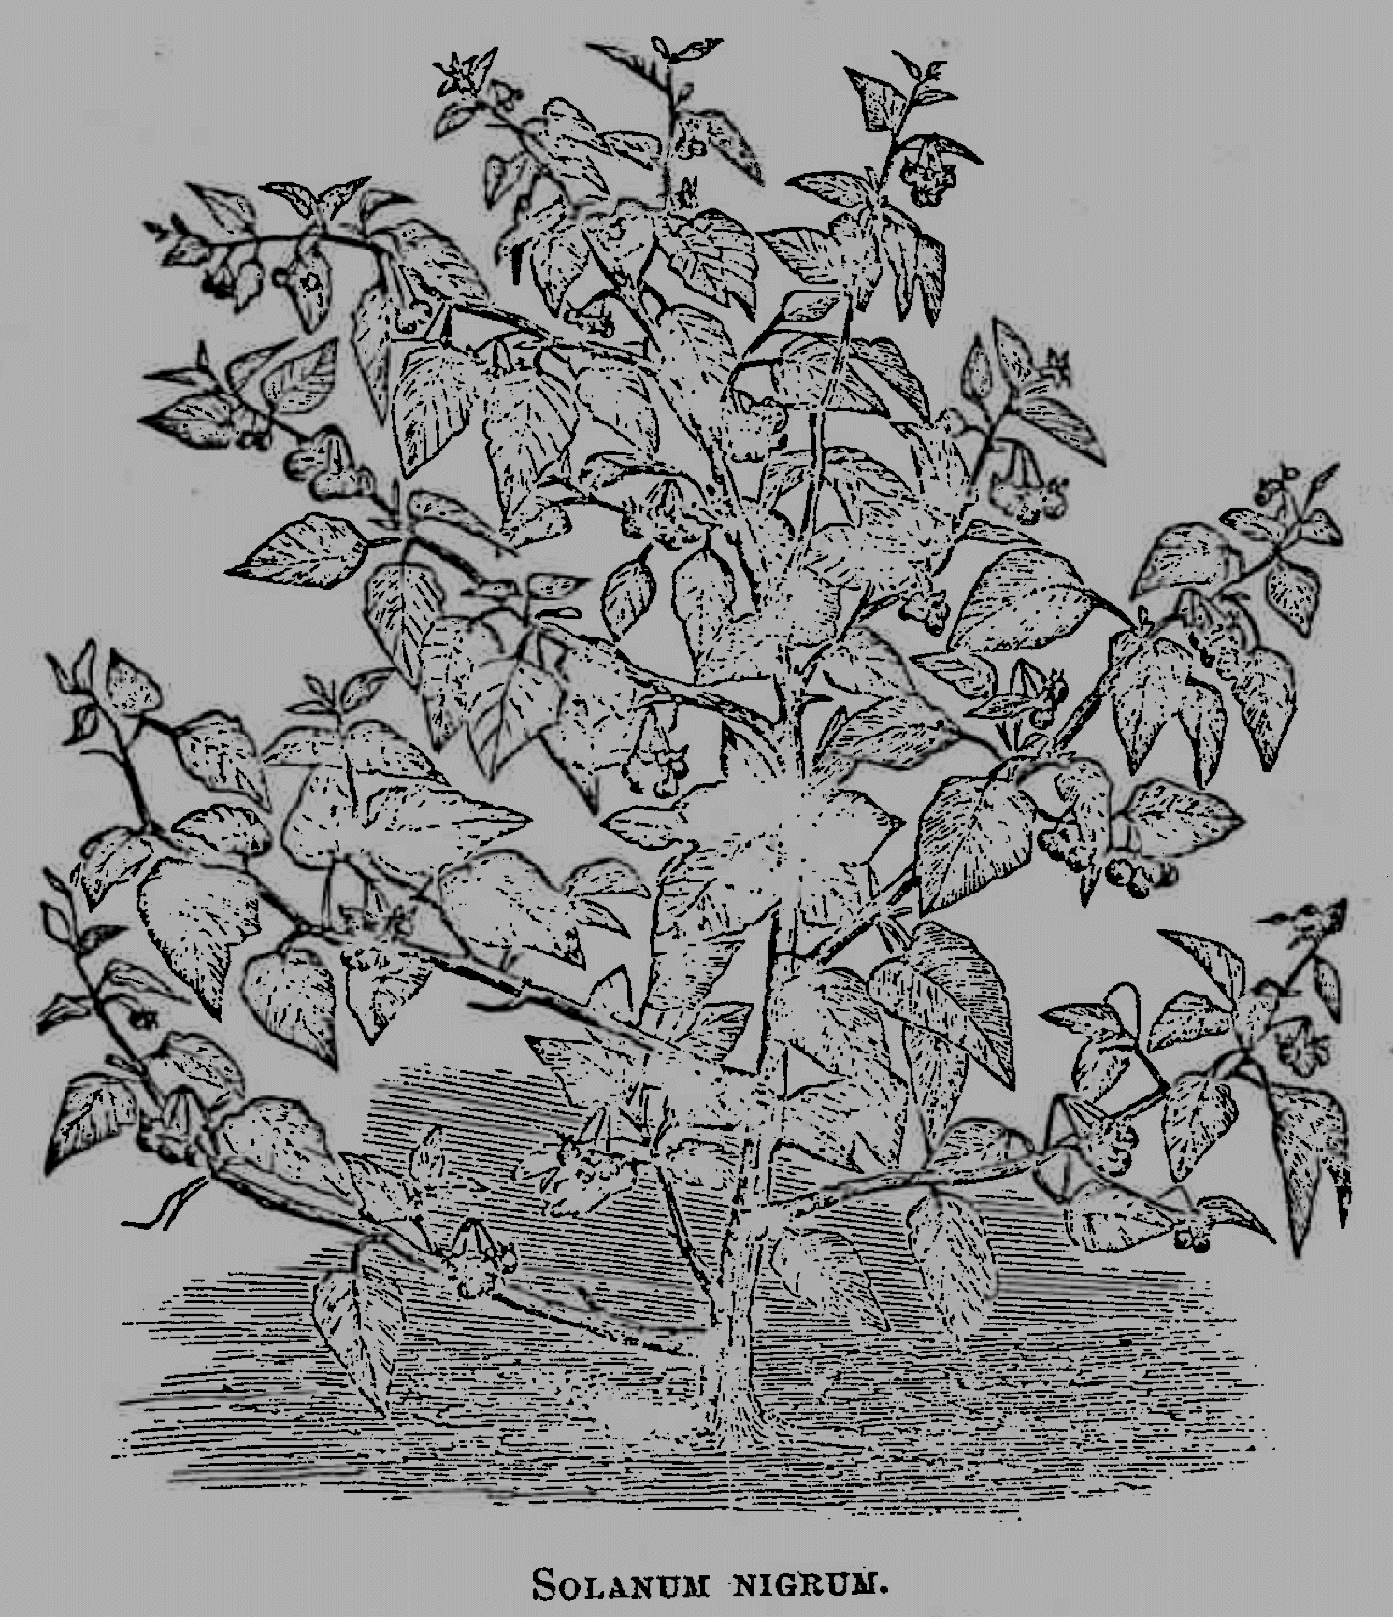
There is a summary of the views of Dioskorides in Dodoens (1574); a copy of this that M owned is now in the library of the Royal Botanic Gardens Melbourne.
M's report was one of several on the poisoning that Kerr in due course forwarded to the Chief Secretary, James Francis; see D73/4020, unit 663, VPRS 3991 inward registered correspondence, VA 475 Chief Secretary's Department, Public Record Office, Victoria.

